Making an LED(mini light) blink using Scratch

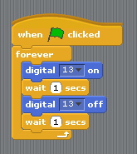
- Create circuit like below
- Plug arduino into computer
- On computer open S4A.
- Create a block system like the picture to right
- Press the green flag
- You should see your LED blink

What do the two blue blocks do?
The digital 13 on tells the arduino to turn on pin 13 which we have connected the LED to so it turns the LED on.
Similarly the digital 13 off turns pin 13 off and so turns the LED off.
Together the six blocks turn on LED, wait a second, turn off LED, wait a second and then repeat.

Circuit Diagram
LED only works if plugged into the circuit the correct way round. The longer leg should be on the right.
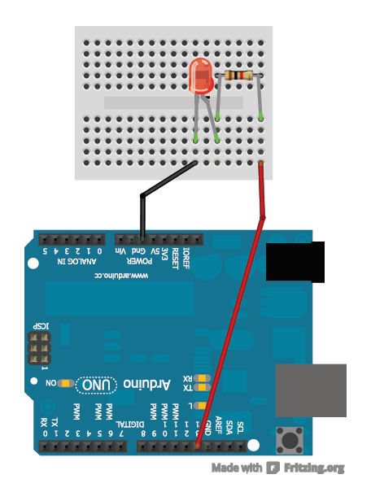

1K ohm Resistor

Connect red wire to Pin 13

